

|  |
| --- |
| GROUP 8Date: 02/09/2023 HOME  MANAGEMENT  SYSTEM  CASE STUDY |
|  |

|  |  |  |
| --- | --- | --- |
| HOME MANAGEMENT SYSTEM | | A Home Management System is a database management system that helps you organize and manage various aspects of your home. It can include features like tracking household expenses, managing inventory, scheduling tasks, and storing important documents. With a well-designed database, you can easily retrieve and analyze data to make informed decisions about your home. |
| 01SCOPE OF PROJECT ER DIAGRAM SCHEMA AND RELATIONSHIPS02CONVERSION INTO TABLES WITH CONSTRAINTS AND FILLING RELEVANT DATA03QUERIES PROCEDURES FUNCTION AND TRIGGERS | SCOPE OF PROJECT  * In home all members require many Document which represent their status and category. * Each member has many different income sources, account and description. * Members has one or many expenses which have different amount and category. * Many investment has done by member which have different market value and risk level. * House member have many different roles which include responsibility, permission etc. * Many member stay in house. * House requires many services for maintaining the status of house. * Those services are provided by provider in order to Fulfill availability and show specialization. * House require many security for protection of members, and it is attend by having alert, notification and alarm setting. * For proper maintained, house has one budget by which we get to know about status of amount. * House requires many inventory item which have their storage ,quality and prices | |
| This project explores the design, development, and implementation of a Home Management System using a DBMS, aiming to make home life more efficient, organized, and enjoyable. Steps includes :  1). Planning  2) Controlling  3) Evaluating. | | |
|  | | |

**ER DIAGRAM**

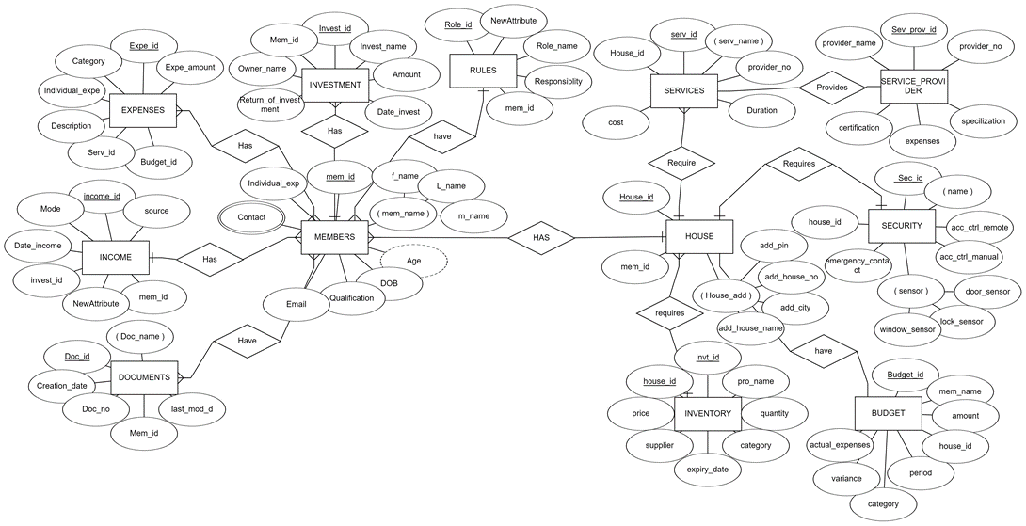

**ENTITY AND THERE ATTRIBUTES**

1. **INVESTMENT**(INVESTMENT_ID , INVESTMENT_NAME , DATE_OF_INVESTMENT , MARKET_VALUE , RISK_LEVEL , AMOUNT , OWNER , RETURN_DATE_OF_INVESTMENT , MEM_ID)
2. **ROLES**(ROLE_ID , ROLE_NAME , STATUS , RESPONSIBILITY , PERMISSION , CATEGORY , START_DATE , END_DATE , MEM_ID )
3. **EXPENSES**(EXP_ID , DATE , CATEGORY , AMOUNT , DESCRIPTION , INV_ID , SER_ID , BUDGET_ID , INDIVISUAL_EXP)
4. **INCOME**(INC_ID , SOURCE , FREQUENCY , DATE , AMOUNT , MODE , INVESTMENT_ID , MEM_ID )
5. **DOCUMENT**(DOC_ID , DEPARTMENT , STATUS , AUTHOR , CREATION_DATE , LAST_MODIFICATION_DATE , OWNER , TITLE , CATEGORY , MEM_ID , )
6. **INVENTARY_ITEMS**(INV_ID , NAME , QUANTITY , CATEGORY , WARRENTY_DATE , WARRENTY_DURATION , SUPPLIER , PURCHASE_DATE , PRICE , HOUSE_ID )
7. **BUDGET**(BUDGET_ID , CATEGORY , NAME , AMOUNT , STARTR_DATE , END_DATE , ACTUAL_EXPENSES , OWNER , VARIANCE , CATEGORY , HOUSE_ID)
8. **SECURITY(**SEC_ID , NAME , ACC_CONTROL_REMOTE , ACC_CONTROL_MANUAL , EMERGENCY_CONTACT , STATUS , PANIC_BUTTON_SENSOR , DOOR_SENSOR , WINDOW_SENSOR , SMART_LOCK_SENSOR , VIDEO_DOORBELL_SENSOR , HOUSE_ID)
9. **SERVICES**(SER_ID , NAME , COST , PROVIDER_CONTACT , SCHEDULE , FREQUENCY , STATUS , DURATION , SER_PRO_ID , HOUSE_ID)
10. **SERVICE_PROVIDER**(SER_PRO_ID , NAME , CONTACT_NO , CONTACT_LOCATION , SPECILIZATION , RATING , PRICE ,CERTIFICATION)
11. **HOUSE**(HOUSE_ID , NAME , ADD_HOUSE_NO , ADD_CITY , ADD_STREET , ADD_PIN , MEM_ID)
12. **MEMBERS**(MEM_ID , NAME , AGE , DOB , QUALIFICATIONS , EMAIL_ID , CONTACT_NO , GENDRE , INDIVISUAL_EXP)
13. **MEM_ EXP** ( MEM_EXP_ID , MEM_ID , EXP_ID )
14. MEM_DOC_ID , MEM_ID , DOC_ID)

**RELATIONSHIPS**

1. ONE MEMBER CAN HAVE MANY INCOME SOURCES

* RELATIONSHIP: ONE TO MANY(MEMBERS TO INCOME)
* FOREIGN KEY: MEM_ID IN INCOME REFERING MEMBERS

1. ONE MEMBER CAN HAVE MANY INVESTMENT

* RELATIONSHIP: ONE TO MANY (MEMBERS TO INVESTMENST)
* FOREIGN KEY: MEM_ID IN INVESTMENST REFERING MEMBERS

1. ONE MEMBER CAN HAVE MANY ROLES

* RELATIONSHIP: ONE TO MANY ( MEMBERS TO ROLES)
* FOREIGN KEY : MEM_ID IN ROLES REFERING MEMBERS

1. MORE THAN ONE MAMBER CAN HAVE MORE THAN ONE KINDS OF EXPENSES

* RELATIONSHIP : MANT TO MANY (MEMBERS TO EXPENSES)
* CREATE A JUNCTION TO REPRESENT THIS RELATIONSHIP : MEM_ EXP
* MEM_ EXP ( MEM_EXP_ID , MEM_ID , EXP_ID )

1. ONE MEMBER CAN HAVE MANY DOCUMENTS AND MANY MEMBERS CAN BE ASSOCIATED WITH ONE DOCUMENT

* RELATIONSHIP : MANT TO MANY(MEMBERS TO DOCUMENTS)
* CREATE A JUNCTION TO REPRESENT THIS RELATIONSHIP : MEM_DOC
* MEM_DOC( MEM_DOC_ID , MEM_ID , DOC_ID)

1. MANY MEMBERS CAN STAY IN ONE HOUSE

* RELATIONSHIP : ONE TO MANY (HOUSE TO MEMBERS)
* FOREIGN KEY : MEM_ID IN HOUSES REFERING MEMBERS

1. MANY INVENTARY ITEMS ARE REQUIRE IN A HOUSE

* RELATIONSHIP : ONE TO MANY(HOUSE TO INVENTARY_ITEMS)
* FOREIGN KEY : HOUSE_ID IN INVENTARY_ITEMS REFERING HOUSE

1. ONE HOUSE HAS ONLY ONE BUDGET

* RELATIONSHIP : ONE TO ONE ( HOUSE TO BUDGET )
* FOREIGN KEY : HOUSE_ID IN BUDGET REFERING HOUSE

1. ONE HOUSE REQUIRES MANY SERVICES PROVIDER BY MANY SERVICE_PROVIDERS

* SERVICES WILL HAVE FOREIGN KEYS OF SERVICES_PROVIDER(SER_PRO_ID) AND HOUSE(HOUSE_ID)

1. ONE HOUSE NEEDS ONLY ONE SECURITY SYSTEM

* RELATIONSHIP : ONE TO ONE (HOUSE TO SECURITY_SYSTEM)
* FOREIGN KEY : HOUSE_ID IN SECURITY

**TABLE CREATION AND INSERTING VALUES:**

create table Investment

(

investment_id varchar(6) primary key,

investment_name varchar(20)not null,

date_of_invest date,

market_value number(10),

risk_percentage number(5),

amount number(10) check(amount>0),

return_of_invesment date,

mem_id varchar(6) constraint c20 references Members(mem_id),

owner_name varchar(6)

);

create table Roles

(

role_id varchar(6) primary key,

role_name varchar(20) not null,

responsibility varchar(20),

mem_id varchar(6) constraint c3 references Members(mem_id)

);

create table expenses

(

exp_id varchar(6) primary key,

category varchar(10),

expe_amount number(7) check(expe_amount>0),

description varchar(20),

inventary_id varchar(6) constraint c19 references inventory(inv_id),

serv_id varchar(6) constraint c18 references Service(serv_id),

budget_id varchar(6) constraint c17 references Budget(budget_id),

individual_exp varchar(10)

);

create table Income

(

inc_id varchar2(6) primary key,

source char(10) not null,

inc_Date date,

amount number(7) check(amount>0),

mode_of_inc varchar2(10),

investment_id varchar2(6) constraint c5 references Investment(investment_id),

mem_id varchar2(6) constraint c4 references Members(mem_id)

);

create table Document

(

doc_id varchar(6) primary key,

doc_name varchar2(20),

creation_date date,

last_mod_d date,

mem_id varchar(60) constraint c6 references Members(mem_id),

doc_no varchar2(20)

);

create table Inventory

(

inv_id varchar(6) primary key,

pro_name char(20) not null,

quantity varchar(5),

category varchar(10),

expiry_dur date,

supplier char(10),

price number(7) check(price!=0),

house_id varchar(6) constraint c7 references House(house_id)

);

create table budget

(

budget_id varchar(6) primary key,

category varchar(10),

men_name char(20) not null,

amount number(8) check(amount>0),

actual_expense varchar(10),

period number(5),

variance varchar(10),

house_id varchar(6) constraint c8 references House(house_id)

);

create table Security

(

sec_id varchar(6) primary key,

acc_control_remote varchar(20),

emergency_contact number(10),

window_sensor varchar(10),

lock_sensor varchar(10),

door_sensor varchar(10),

house_id varchar(6) constraint c9 references House(house_id),

acc_ctrl_manual varchar(10),

sensor varchar2(10)

);

create table Service

(

serv_id varchar(6) primary key,

serv_name char(20) not null,

cost number(10) check(cost>0),

provider_no number(10),

duration varchar(10),

ser_pro_id varchar(6) constraint c16 references Service_provider(ser_pro_id),

house_id varchar(6) constraint c15 references House(house_id)

);

create table service_provider

(

ser_pro_id varchar(6) primary key,

provider_name char(20) not null,

provider_no number(10),

specilization varchar(30),

expenses number(6) check(expenses!=0),

certification char(20)

);

create table House

(

house_id varchar(6) primary key,

name char(20) not null,

add_house_no varchar(5),

add_city char(15),

add_street varchar(20),

add_pin number(6)

);

create table Members

(

mem_id varchar(6) primary key,

mem_name char(10),

f_name char(10) not null,

l_name char(10) not null,

m_name char(10) not null,

age number(3) not null,

DOB date,

qualification varchar(20),

email_id varchar(20),

contact_no number(10),

gender char(6),

individual_exp varchar(10)

);

create table Member_exp

(

mem_exp_id varchar(6) primary key,

mem_id varchar(6) constraint c12 references members(mem_id),

exp_id varchar(6) constraint c13 references Expenses(exp_id)

);

create table Mem_doc_details

(

mem_doc_id varchar(6) primary key,

mem_id varchar(6)constraint c11 references Members(mem_id),

doc_id varchar(6) constraint c10 references Document(doc_id)

);

**INSERTION OF VALUES IN SCHEMAS**

ROLES

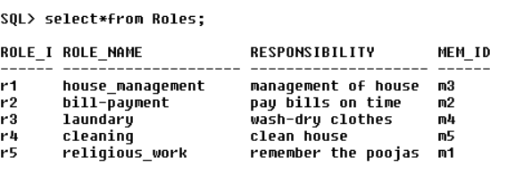

INCOME

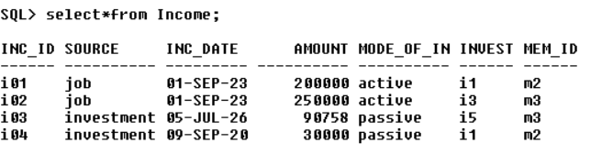

DOCUMENTS

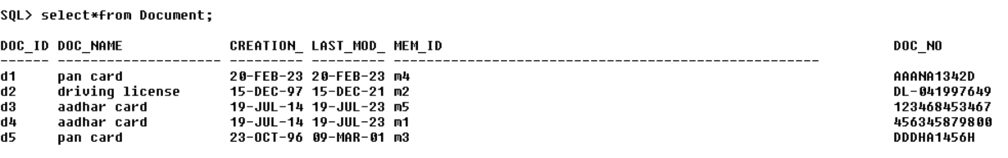

INVENTORY

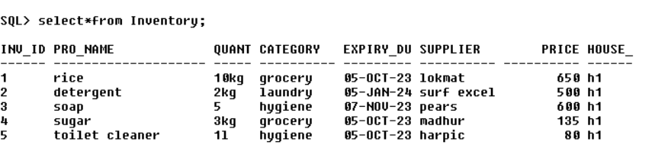

BUDGET

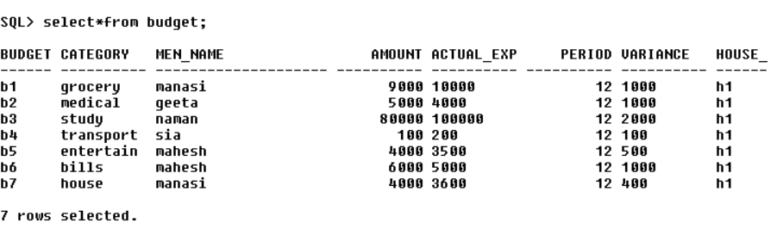

security

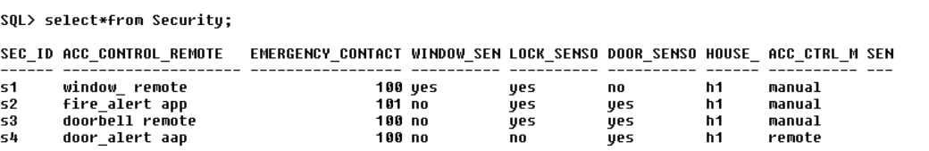

Service

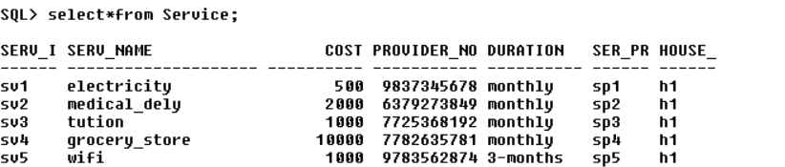

service_provider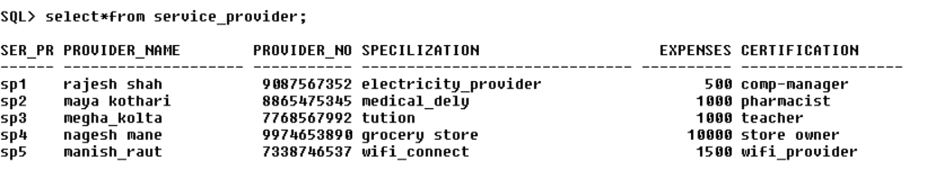

expenses

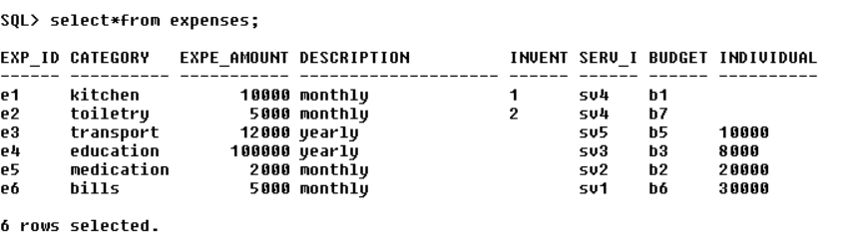

member_exp

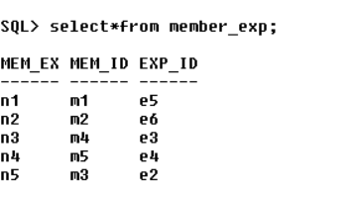

mem_doc_details

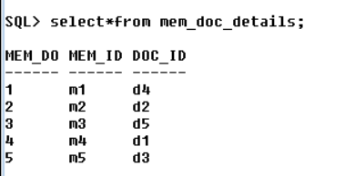

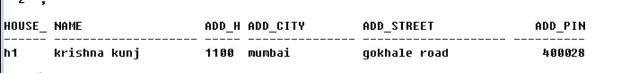

**MEMBERS**

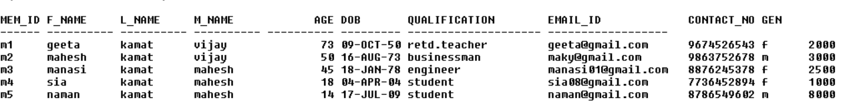

**INVESTMENT**

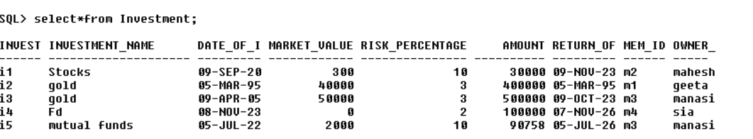

**QUERIES**

**1.how much years are left for maturing the fd. 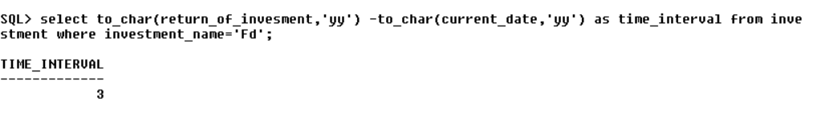2.display the service name and its provider name** 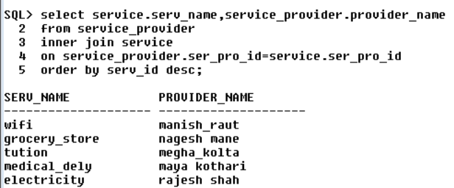

**3.which member has the maximum investment and what is that amount?** 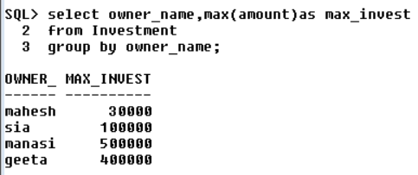

**4.what is the total amount paid by a member in the house budget from least to most?**

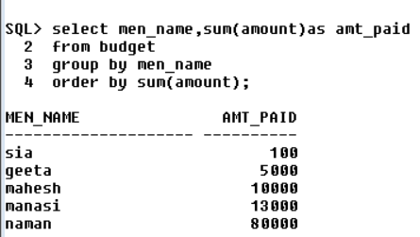

**5.concatenate the first name and middle name of the members and there age.** 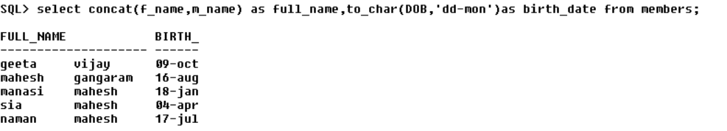

**6.display the details of the budget where expense id is e3** 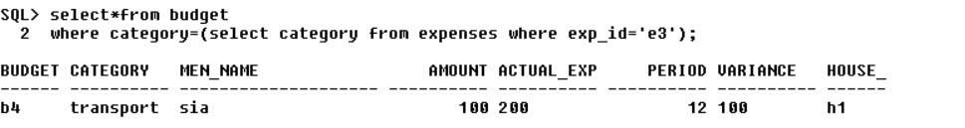

**7.display the document name and number where the member id is m4 or m6** 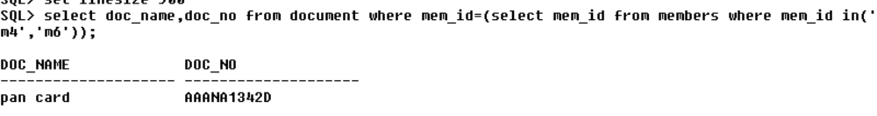

**8.display the source and amount from income where it is greater than all the budget amount.** 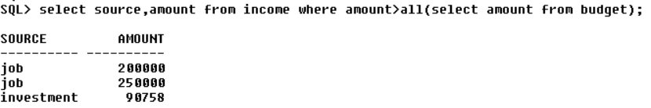

**9.display the categories of things from budget and expenses and the total amount spend on it using joints.**

**.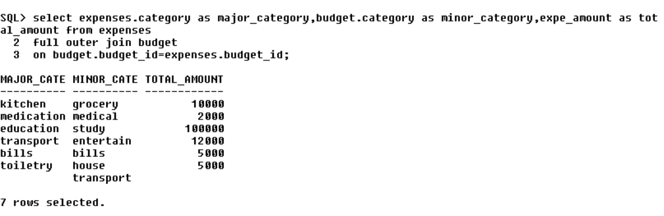 10.which member spends amount of money starts with the digit 2?** 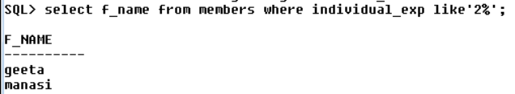

**FUNCTION**

**1.to find the total income received by individual that is from his salary and investments**

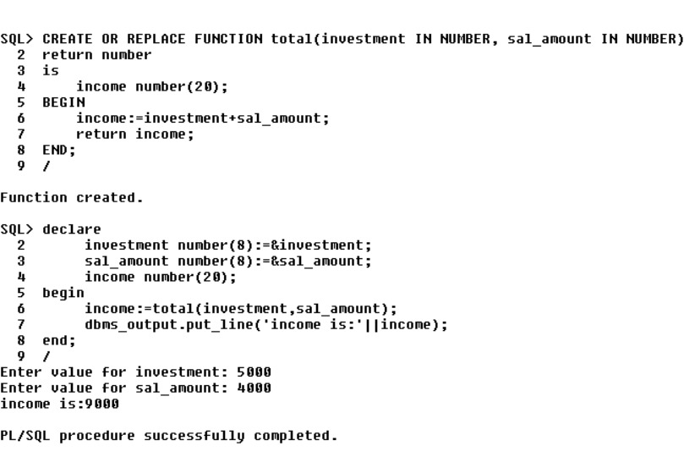

**2. to find the total expenses on the security and inventory things**

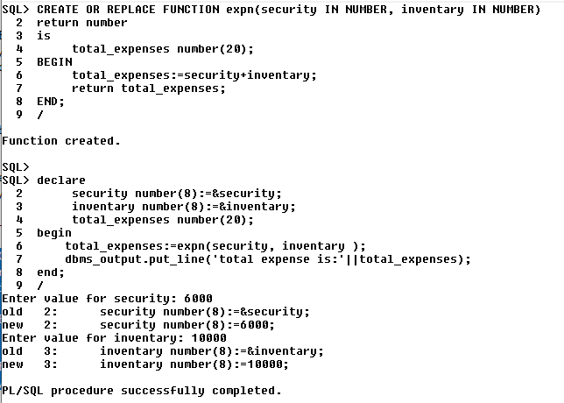

**3. Function**

**3. Function to show document of member by accepting member's id :**

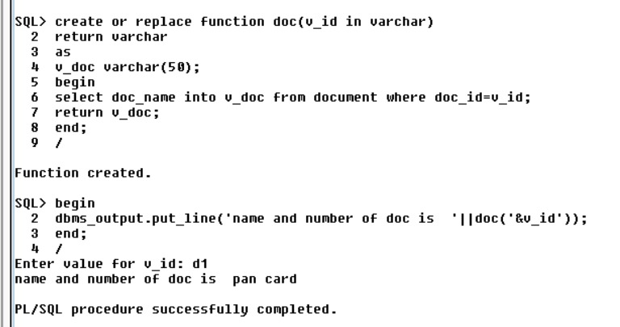

**4. function to show number of service provider by accepting service id:**

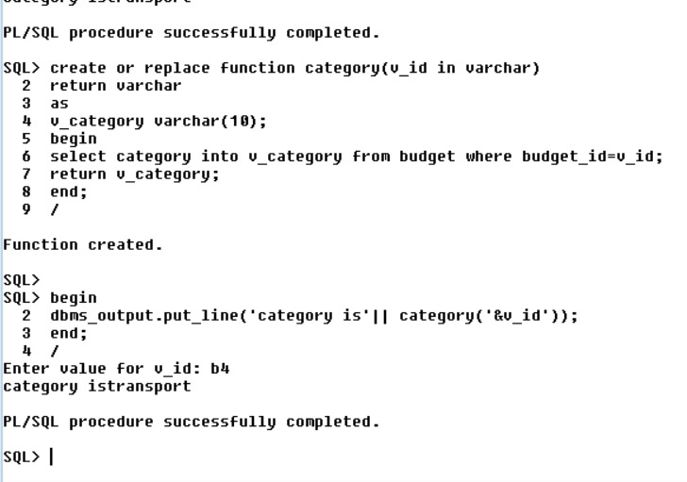

**5. Function to show the category of budget by accepting budget id:**

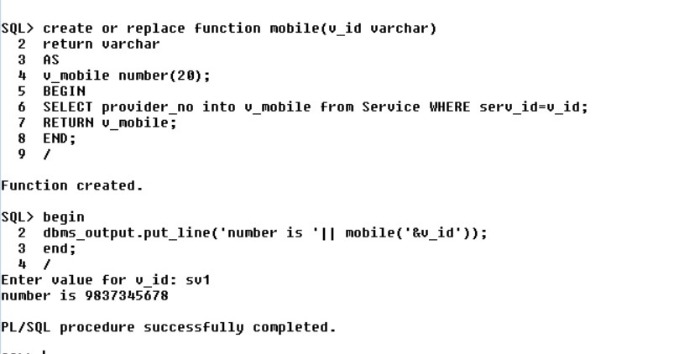

**PROCEDURES**

***1. TO FIND EMAIL ID FROM MEMBER ID:***

create or replace procedure email(v_id in varchar,v_email out varchar)

is

begin

select email_id into v_email from members where mem_id=v_id;

end email;

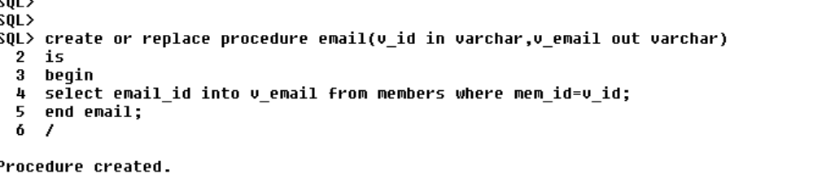

declare

v_id varchar(50);

v_email varchar(50);

begin

v_id:='&v_id';

email(v_id,v_email);

dbms_output.put_line('email id is'||v_email);

end;

/

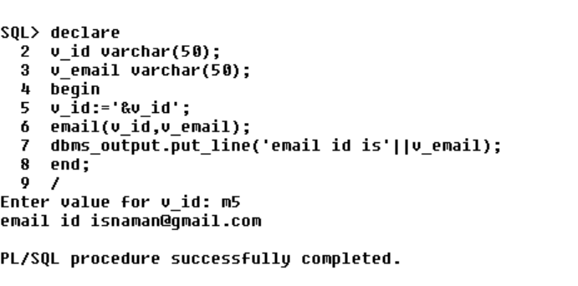

***2.TO FIND THE MARKET VALUE OF INVESTMENT FROM THE INVESTMENT NAME***:

create or replace procedure marketvalue(v_inname in varchar,v_marvalue out number)

is

begin

select market_value into v_marvalue from investment where investment_name=v_inname;

end marketvalue;

exec marketvalue;

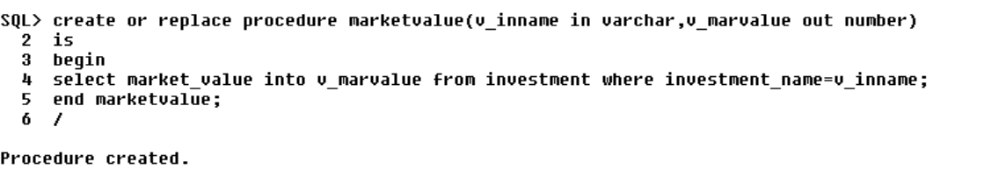

declare

v_inname varchar(20);

v_marvalue number(20);

begin

v_inname:='&v_inname';

marketvalue(v_inname,v_marvalue);

dbms_output.put_line('the marketvalue is'||v_marvalue);

end;

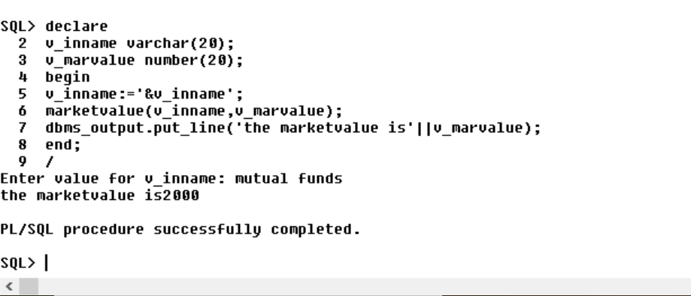

***3.) procedure to find last modified date of document by taking document id***:

Code:

create or replace procedure lastmodified(v_id in varchar , v_lastmodify out date)

is

begin

select last_mod_d into v_lastmodify from document where doc_id=v_id;

end;

/

Output:

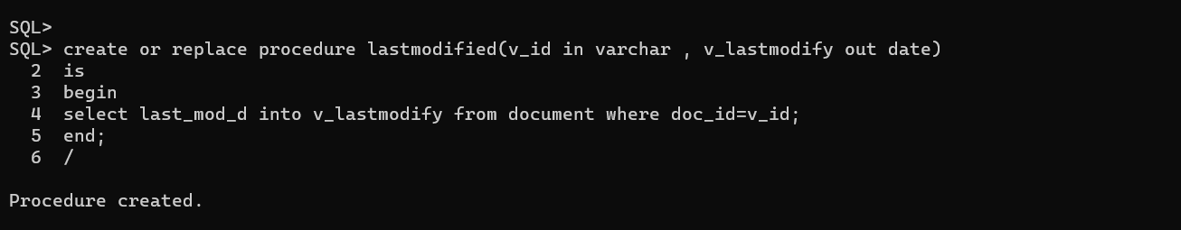

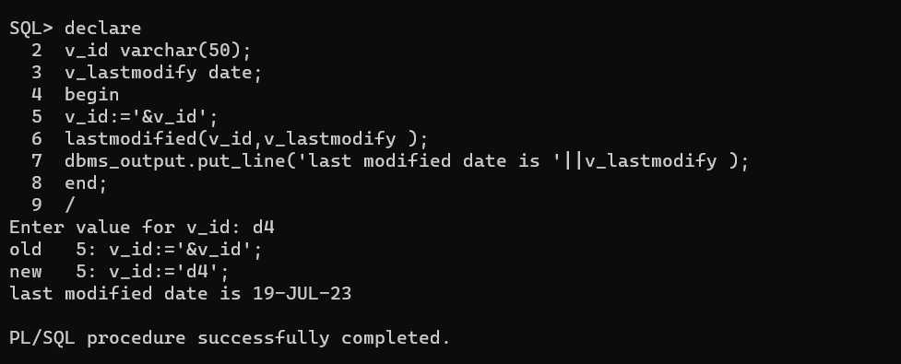

**TRIGGERS**

**1. Trigger to calculate the total expenses for a budget when a new expense is added:**

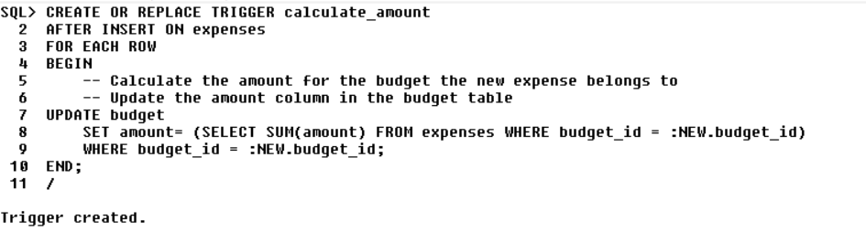

**2. Trigger to update the quantity of an inventory item when it is purchased:**

**‘’’**

**/** 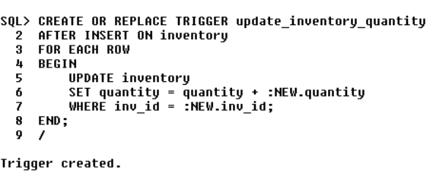

**CONCLUSION**

In conclusion, the Home Management System implemented within a Database Management System represents a significant step forward in the quest for efficient and organized domestic life. This project has demonstrated the potential of technology to simplify and enhance the management of various household responsibilities.

The advantages of such a system are manifold. It allows homeowners to maintain financial records, track expenses, and set budgets with ease. It keeps a comprehensive inventory of household items, ensuring that supplies are never depleted unexpectedly. It enables efficient scheduling of tasks, from cleaning and maintenance to appointments and family events. Furthermore, the database-driven approach empowers users to analyze trends and make data-driven decisions to optimize their home management strategies.

As our lives become increasingly busy and interconnected, the Home Management System using a DBMS stands as a beacon of order and control amidst the chaos. It not only saves time but also provides peace of mind, knowing that every aspect of home life is under control. With continued development and integration with smart home technologies, this system has the potential to revolutionize how we manage our homes in the future, making them not only more efficient but also more comfortable and enjoyable places to live.